**Details Master CustTable form**

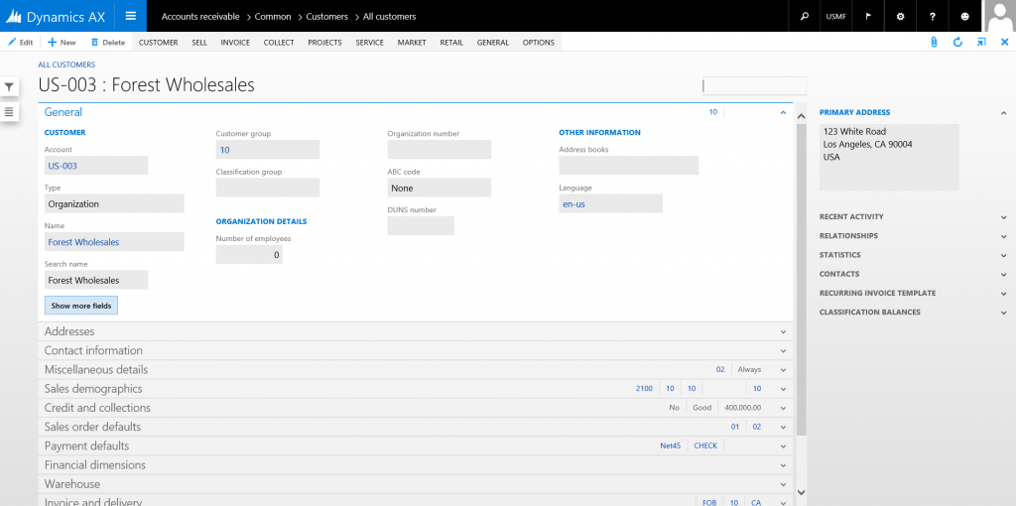

**Details Transaction SalesTable form**

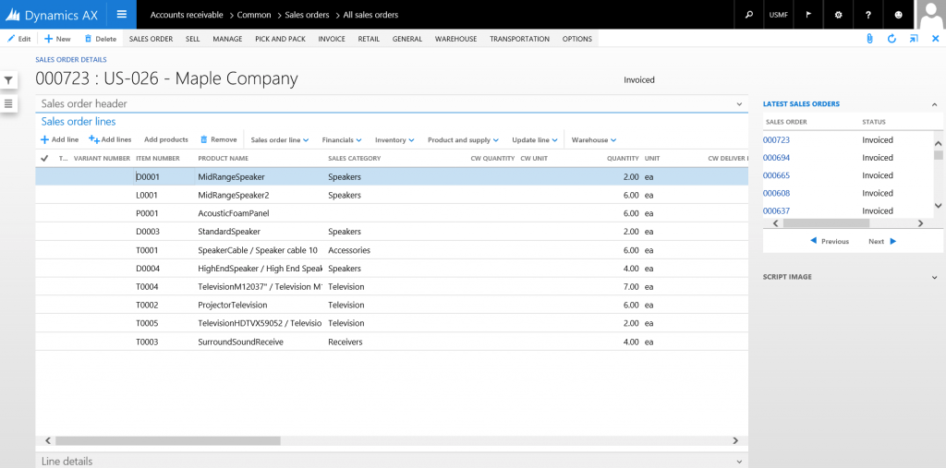

**ListPage SalesTableListPage form**

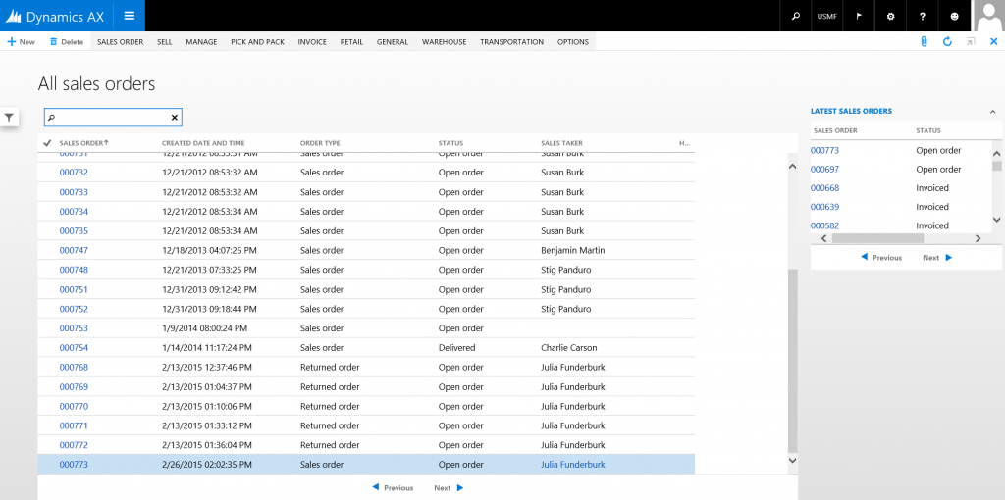

**Simple Details AgreementLine form**

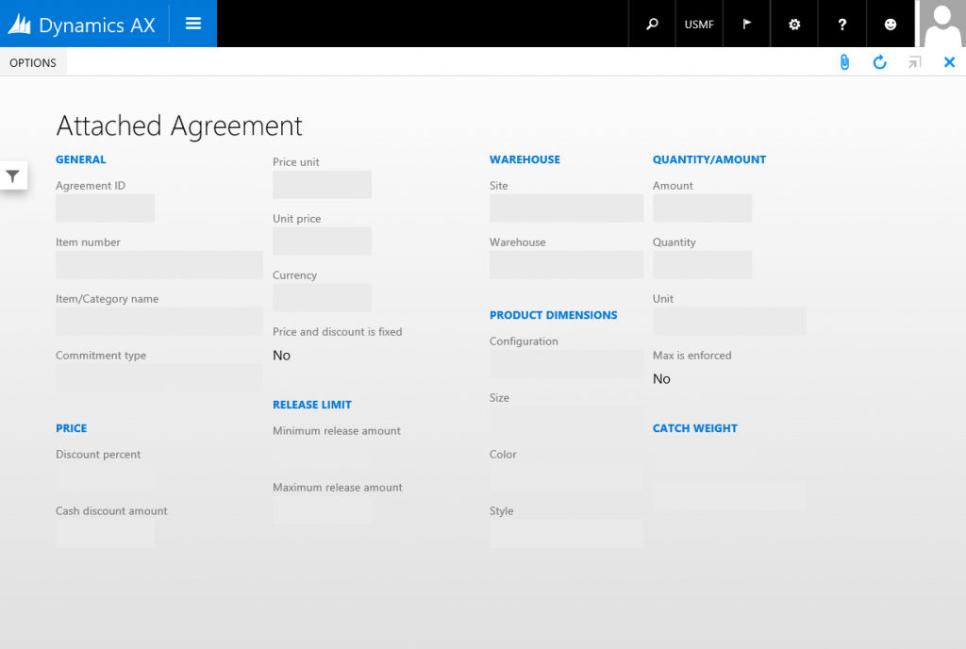

**Sim****ple List CustGroup form**

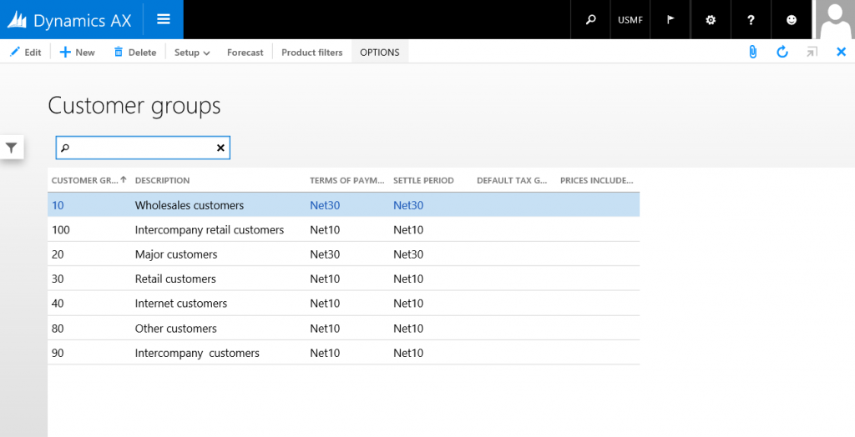

**Sim****ple List and Details PaymTerm form**

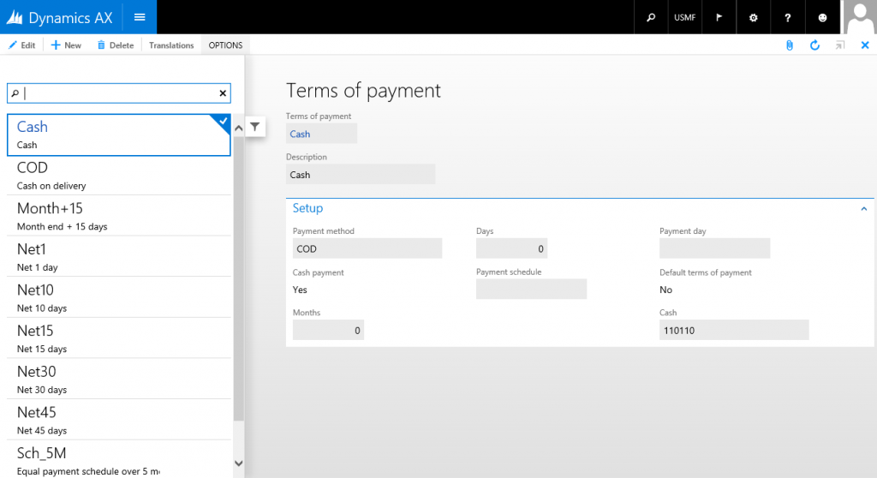

**T****able of Contents CustParameters form**

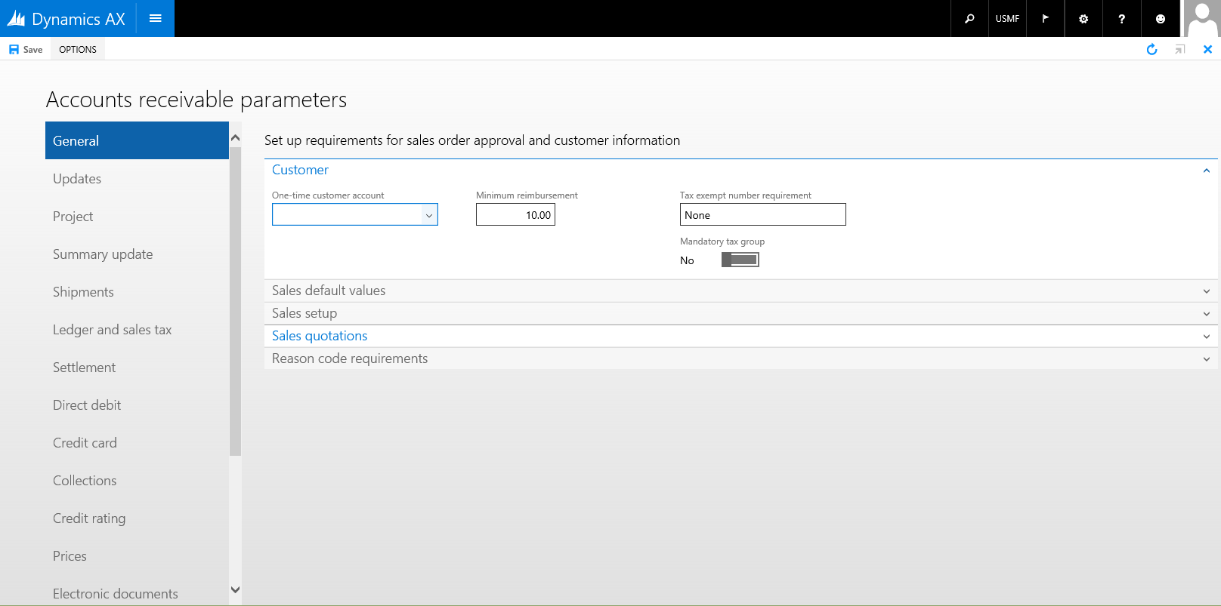

**Task Double HRMAbsenceTableHistory form**

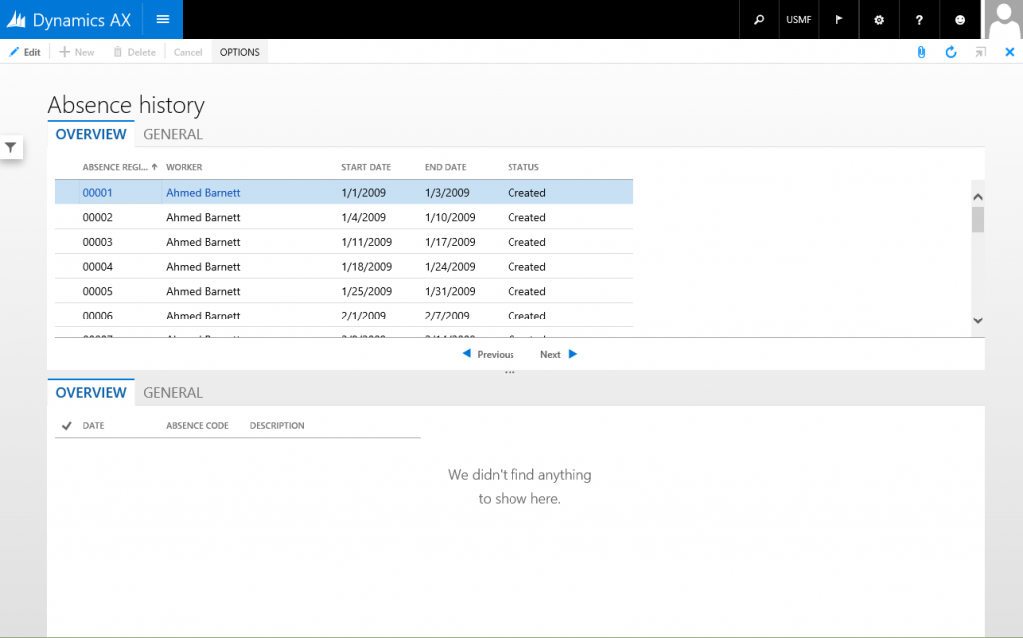

**Task Single LedgerJournalTable form**

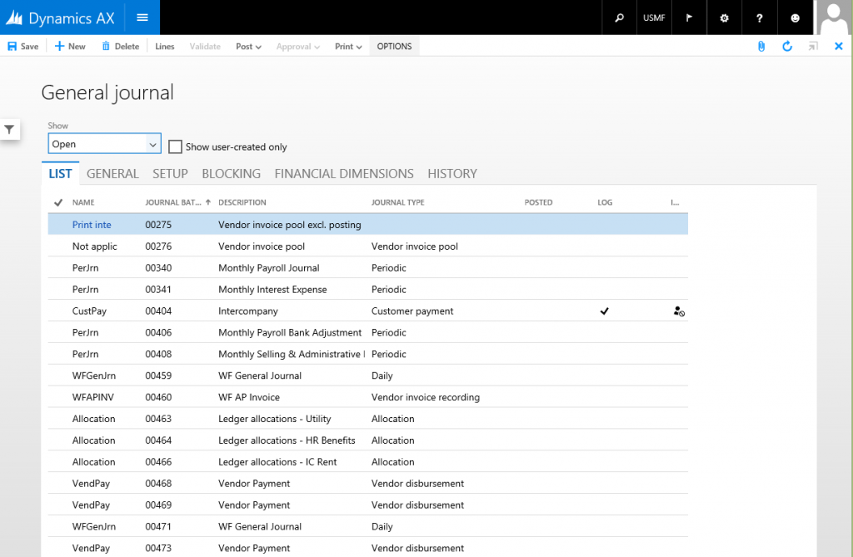

**Wizard WrkCtrBulkResReqEditWizard form**

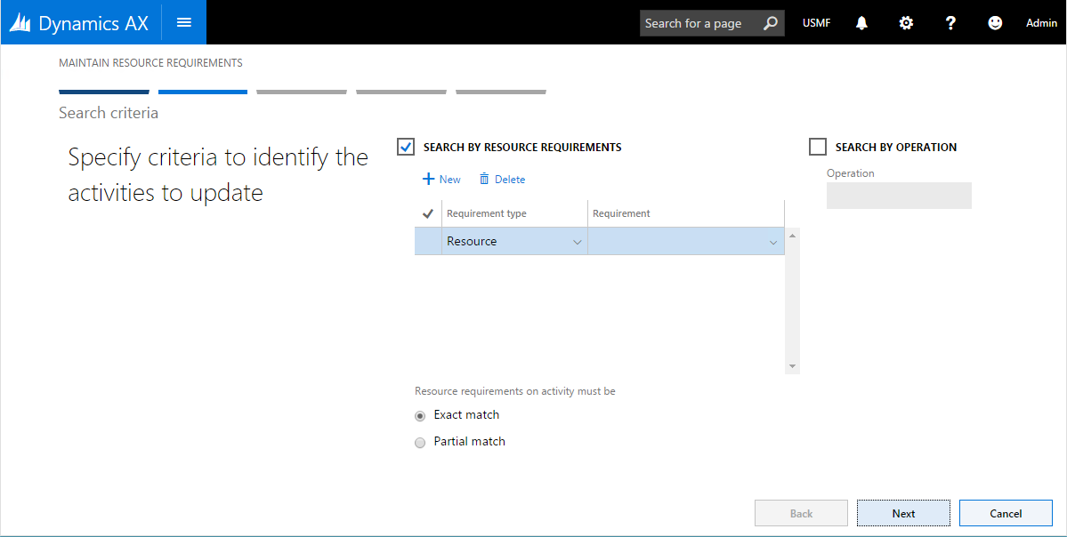

**Workspace FMClerkWorkspace form**

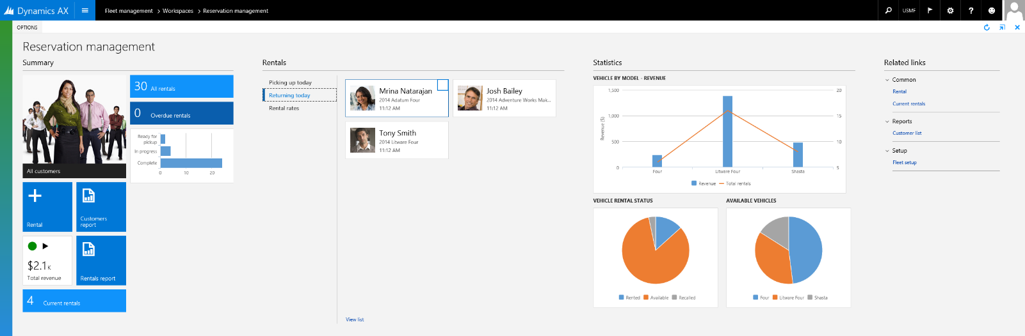

**Advanced selection ProcCategoryAddVendor form**

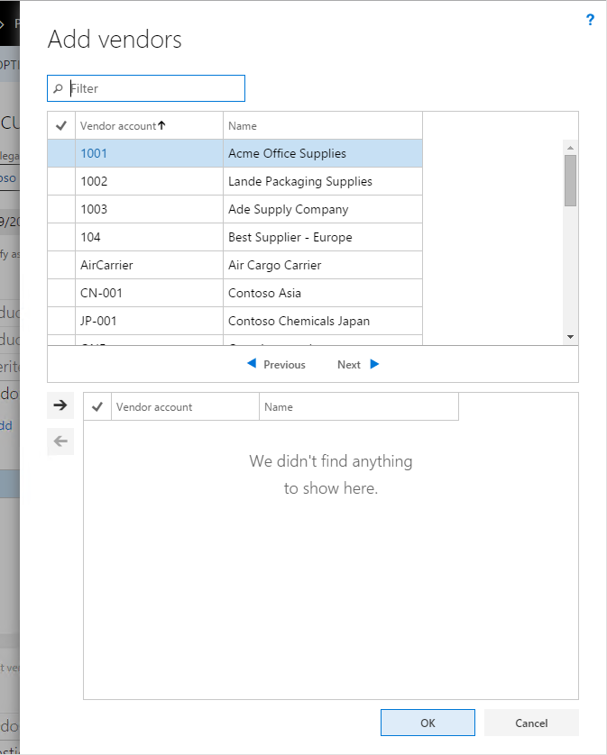

**Dialog ProjTableCreate form**

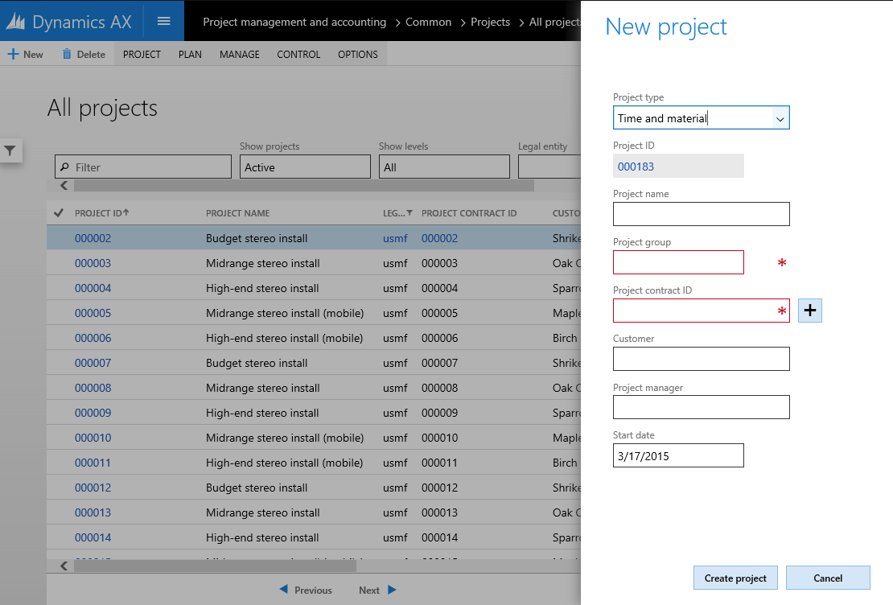

**Drop Dialog CustCollectionsNewActivityAction form**

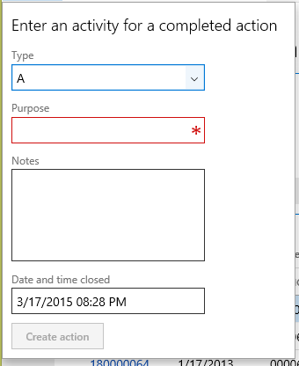

**Lookup SysLanguageLookup**

